**PRACTICAL - 1**

**Aim:** Implement code to

i. read an image, observe image as function along with its attributes,create a sample image and store it for grayscale images

ii. read an image, observe image as function along with its attributes, split image in different color image planes, merge splitted image plane and observe effect on merged image by changing red, green and blue image plane values

iii. convert color image to grayscale and HSV image and observe HSV values

iv. create images of different shapes

v. resize image with different types of interpolation

**Program:**

i.

% Read an image and observe its attributes

imagePath = 'saulgoodman.png';

originalImage = imread(imagePath);

disp(['Original Image Size: ', num2str(size(originalImage))]);

disp(['Image Data Type: ', class(originalImage)]);

% Create a sample grayscale image

sampleImage = randi([0, 255], [300, 300], 'uint8');

imwrite(sampleImage, 'sample_grayscale_image.jpg');

**Output:**

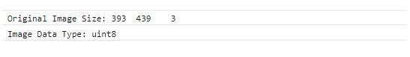

**Program:**

ii.

% Read a color image and observe its attributes

colorImagePath = 'saulgoodman.png';

colorImage = imread(colorImagePath);

disp(['Color Image Size: ', num2str(size(colorImage))]);

disp(['Color Image Data Type: ', class(colorImage)]);

% Split image into different color planes (R, G, B)

r = colorImage(:, :, 1);

g = colorImage(:, :, 2);

b = colorImage(:, :, 3);

% Merge the color planes

mergedImage = cat(3, r, g, b);

% Observe the effect by changing red, green, and blue image plane values

% For example, change red plane values:

r = r * 1.5;

% Merge the modified planes

modifiedImage = cat(3, r, g, b);

**Output:**

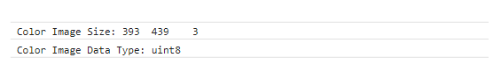

**Program:**

iii.

% Convert color image to grayscale

grayImage = rgb2gray(colorImage);

% Convert color image to HSV

hsvImage = rgb2hsv(colorImage);

% Observe HSV values

disp(['Hue Values (min, max): ', num2str([min(hsvImage(:, :, 1)), max(hsvImage(:, :, 1))])]);

disp(['Saturation Values (min, max): ', num2str([min(hsvImage(:, :, 2)), max(hsvImage(:, :, 2))])]);

disp(['Value (Brightness) Values (min, max): ', num2str([min(hsvImage(:, :, 3)), max(hsvImage(:, :, 3))])]);

**Output:**

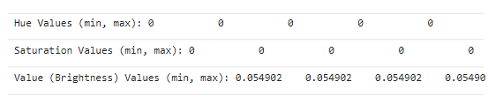

**Program:**

iv.

% Create images of different shapes

rectangleImage = zeros(300, 400);

rectangleImage(50:250, 100:300) = 255;

diamondImage = zeros(300, 400);

[x, y] = meshgrid(1:400, 1:300);

diamondMask = abs((x - 200) / 200) + abs((y - 150) / 150) <= 1;

diamondImage(diamondMask) = 255;

% Display or save the created images

imwrite(rectangleImage, 'rectangle_image.jpg');

imwrite(diamondImage, 'diamond_image.jpg');

**Output:**

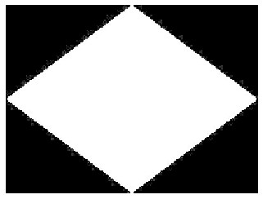

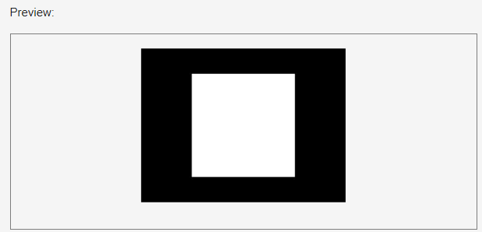

**Program:**

v.

% Read an image to resize

imagePathToResize = 'saulgoodman.png';

imageToResize = imread(imagePathToResize);

% Resize image with different types of interpolation

resizedNearest = imresize(imageToResize, 0.5, 'nearest');

resizedBilinear = imresize(imageToResize, 0.5, 'bilinear');

resizedBicubic = imresize(imageToResize, 0.5, 'bicubic');

% Save resized images

imwrite(resizedNearest, 'resized_nearest.jpg');

imwrite(resizedBilinear, 'resized_bilinear.jpg');

imwrite(resizedBicubic, 'resized_bicubic.jpg');

**Output:**

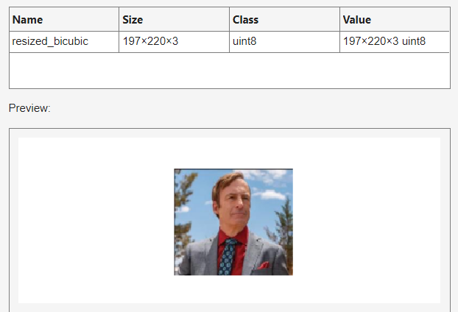

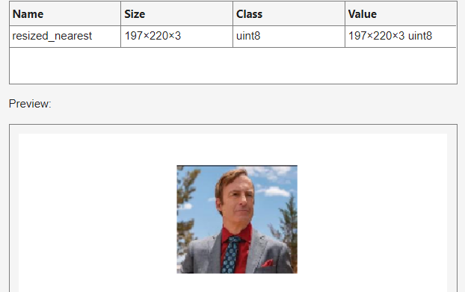

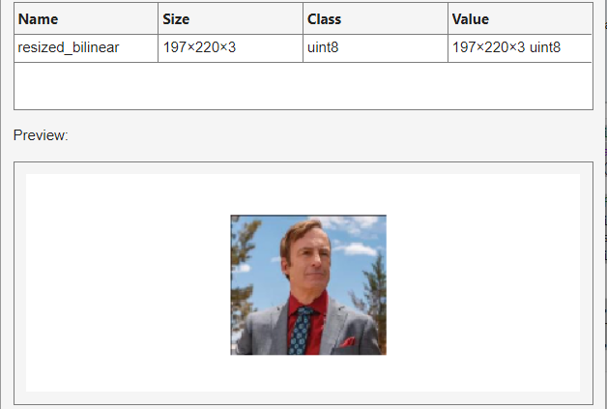

**Conclusion:** In this practical, I performed image attribute observation, color channel manipulation, color space conversion, shape generation, and image resizing with different interpolation methods using OpenCV.

**PRACTICAL - 2**

**Aim:** Implement code to

i. obtain negative of given images

ii. perform contrast stretching on given images

iii. perform thresholding on given images

iv. perform Otsu’s thresholding on given images

v. perform log transformation on given images

vi. perform gamma correction on given images

**Program:**

i.

% Read the original image

originalImage = imread('pexels-brett-sayles-6424244.jpg');

% Obtain negative of the image

negativeImage = 255 - originalImage;

% Display or save the negative image

imshow(negativeImage);

imwrite(negativeImage, 'negative_image.jpg');

**Output:**

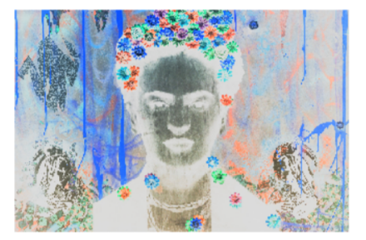

**Program:**

ii.

% Read the original image

originalImage = imread('pexels-brett-sayles-6424244.jpg');

% Convert the original image to double data type

originalImage = double(originalImage);

% Perform contrast stretching

minIntensity = min(originalImage(:));

maxIntensity = max(originalImage(:));

stretchedImage = uint8((originalImage - minIntensity) * (255 / (maxIntensity - minIntensity)));

% Display or save the contrast-stretched image

imshow(stretchedImage);

imwrite(stretchedImage, 'contrast_stretched_image.jpg');

**Output:**

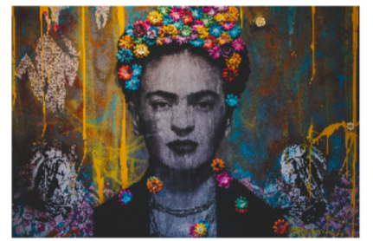

**Program:**

iii.

% Read the grayscale image

grayImage = imread('grayscale_image.jpg');

% Set a threshold value

threshold = 128;

% Perform thresholding

thresholdedImage = grayImage > threshold;

% Display or save the thresholded image

imshow(thresholdedImage);

imwrite(thresholdedImage, 'thresholded_image.jpg');

**Output:**

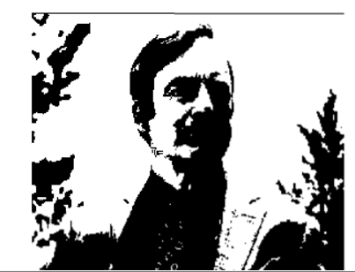

**Program:**

iv.

% Read the grayscale image

grayImage = imread('grayscale_image.jpg');

% Perform Otsu's thresholding

threshold = graythresh(grayImage);

otsuThresholdedImage = imbinarize(grayImage, threshold);

% Display or save the Otsu's thresholded image

imshow(otsuThresholdedImage);

imwrite(otsuThresholdedImage, 'otsu_thresholded_image.jpg');

**Output:**

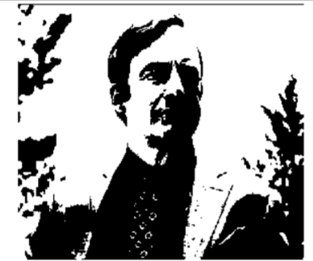

**Program:**

v.

% Read the grayscale image

grayImage = imread('grayscale_image.jpg');

% Perform log transformation

c = 1; % Scaling factor

logTransformedImage = c * log(1 + double(grayImage));

% Scale the log-transformed image to [0, 255]

logTransformedImage = uint8((logTransformedImage / max(logTransformedImage(:))) * 255);

% Display or save the log-transformed image

imshow(logTransformedImage);

imwrite(logTransformedImage, 'log_transformed_image.jpg');

**Output:**

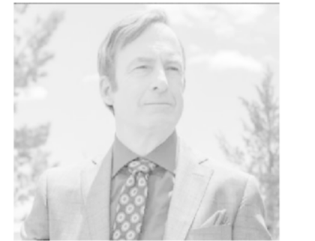

**Program:**

vi.

% Read the grayscale image

grayImage = imread('grayscale_image.jpg');

% Set gamma value (adjust as needed)

gamma = 1.5;

% Perform gamma correction

gammaCorrectedImage = imadjust(grayImage, [], [], gamma);

% Display or save the gamma-corrected image

imshow(gammaCorrectedImage);

imwrite(gammaCorrectedImage, 'gamma_corrected_image.jpg');

**Output:**

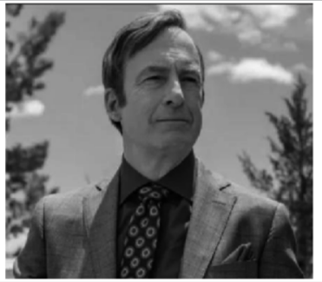

**Conclusion:** In this practical, I implemented various image manipulation techniques, including obtaining negative images, enhancing contrast through stretching, segmenting objects using thresholding, applying automatic thresholding with Otsu's method, adjusting contrast with logarithmic transformation, and fine-tuning brightness and contrast using gamma correction.

**PRACTICAL - 3**

**Aim**: Implement code to

i. apply intensity slicing on given images

ii. apply bit plane slicing on given images and observe information on different bit planes

iii. calculate histograms on different contrast images.

iv. apply normal histogram equalization and CLAHE histogram equalization on given images.

v. apply histogram matching on given images

**Program:**

i.

% Read the original grayscale image

originalImage = imread('pexels-brett-sayles-6424244.jpg');

% Define lower and upper thresholds for intensity slicing

lowerThreshold = 100;

upperThreshold = 200;

% Perform intensity slicing

outputImage = originalImage;

outputImage(originalImage >= lowerThreshold & originalImage <= upperThreshold) = 255;

% Display or save the intensity-sliced image

imshow(outputImage);

imwrite(outputImage, 'intensity_sliced_image.jpg');

**Output:**

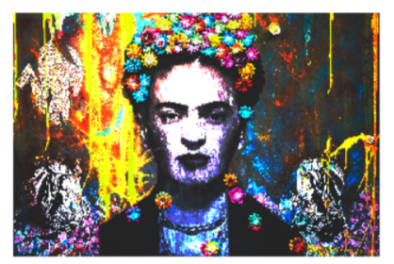

**Program:**

ii.

% Read the original grayscale image

originalImage = imread('rectangle_image.jpg');

% Convert the image to binary representation

binaryImage = imbinarize(originalImage);

% Perform bit plane slicing

bitPlanes = zeros(size(binaryImage, 1), size(binaryImage, 2), 8);

for i = 1:8

bitPlanes(:, :, i) = bitget(originalImage, i);

end

% Display or save bit planes

for i = 1:8

subplot(2, 4, i);

imshow(bitPlanes(:, :, i) * 255);

title(['Bit Plane ', num2str(i)]);

end

**Output:**

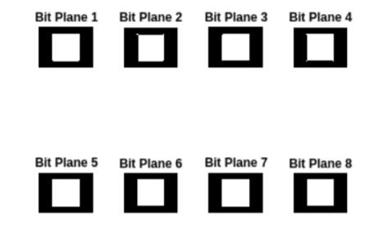

**Program:**

iii.

% Read different contrast images

image1 = imread('download (1).jpeg');

image2 = imread('pexels-brett-sayles-6424244.jpg');

% Calculate histograms

histogramImage1 = imhist(image1);

histogramImage2 = imhist(image2);

% Display histograms

figure;

subplot(2, 1, 1);

bar(histogramImage1);

title('Histogram of Image 1');

subplot(2, 1, 2);

bar(histogramImage2);

title('Histogram of Image 2');

**Output:**

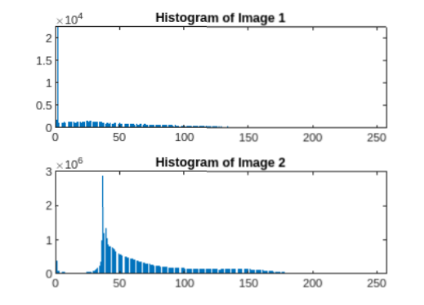



**Program:**

iv.

% Read the original image

originalImage = imread('jesse.png');

% Convert the image to grayscale if it's a color image

if size(originalImage, 3) == 3

originalImage = rgb2gray(originalImage);

end

% Perform normal histogram equalization

histeqImage = histeq(originalImage);

% Perform CLAHE (Contrast Limited Adaptive Histogram Equalization)

claheImage = adapthisteq(originalImage, 'ClipLimit', 0.02, 'Distribution', 'rayleigh');

% Display or save the processed images

imshowpair(histeqImage, claheImage, 'montage');

imwrite(histeqImage, 'histeq_image.jpg');

imwrite(claheImage, 'clahe_image.jpg');

**Output:**

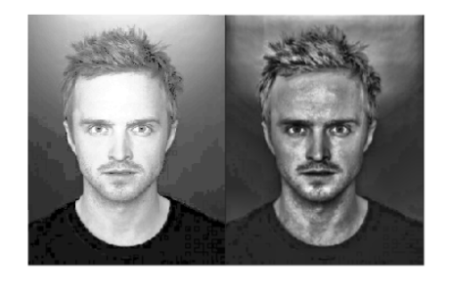

**Program:**

v.

% Read the reference image and the image to be matched

referenceImage = imread('download (1).jpeg');

imageToMatch = imread('jesse.png');

% Perform histogram matching

matchedImage = imhistmatch(imageToMatch, referenceImage);

% Display or save the matched image

imshowpair(referenceImage, matchedImage, 'montage');

imwrite(matchedImage, 'matched_image.jpg');

**Output:**

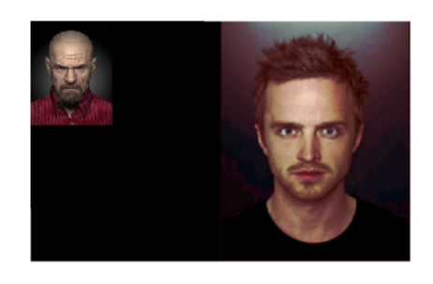

**Conclusion:** In this practical, I learnt image enhancement techniques, such as intensity slicing, bit plane slicing, histogram analysis, histogram equalization (standard and CLAHE), and histogram matching.

**PRACTICAL - 4**

**Aim:** Implement code to

i. perform cross-correlation and convolution on images in spatial domain

ii. apply smoothing spatial filters of different kernel sizes on images

iii. apply sharpening spatial filters of different kernel sizes on images

iv. apply non-linear spatial filters of different kernel sizes on images

v. analyze noise removal with different smoothing spatial filters and non-linear filters

vi. perform unsharp masking and high-boost filtering on different images

**Program:**

i.

% Read the original grayscale image and kernel

originalImage = imread('pexels-brett-sayles-6424244.jpg');

grayImage = rgb2gray(originalImage);

kernel = fspecial('gaussian', [3 3], 1); % Example Gaussian kernel

% Perform cross-correlation

crossCorrelationResult = xcorr2(double(grayImage), kernel);

% Perform convolution

convolutionResult = conv2(double(grayImage), kernel, 'same');

% Display or save the results

imshow(crossCorrelationResult, []);

imwrite(uint8(convolutionResult), 'convolution_result.jpg');

**Output:**

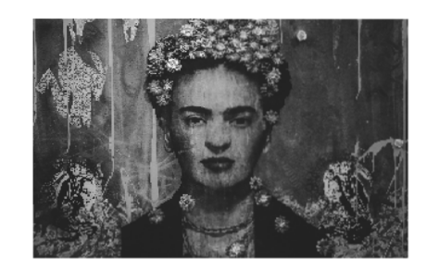

**Program:**

ii.

% Apply smoothing spatial filters with different kernel sizes

smoothedImages = cell(1, 3);

kernelSizes = [3, 5, 7];

for i = 1:length(kernelSizes)

kernel = fspecial('average', kernelSizes(i));

smoothedImages{i} = conv2(double(grayImage), kernel, 'same');

end

% Display or save the smoothed images

for i = 1:length(kernelSizes)

imshow(uint8(smoothedImages{i}), []);

imwrite(uint8(smoothedImages{i}), ['smoothed_image_kernel_', num2str(kernelSizes(i)), '.jpg']);

end

**Output:**

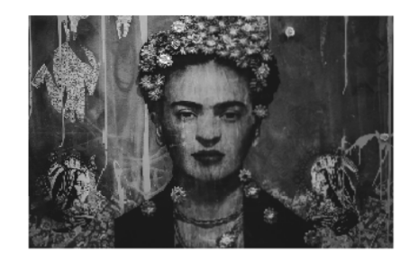

**Program:**

iii.

% Apply sharpening spatial filters with different kernel sizes

sharpenedImages = cell(1, 3);

kernelSizes = [3, 5, 7];

for i = 1:length(kernelSizes)

% Create the kernel for sharpening

kernel = -fspecial('average', kernelSizes(i)) + 2 * fspecial('gaussian', kernelSizes(i), 1);

sharpenedImages{i} = conv2(double(grayImage), kernel, 'same');

end

% Display or save the sharpened images

for i = 1:length(kernelSizes)

imshow(uint8(sharpenedImages{i}), []);

imwrite(uint8(sharpenedImages{i}), ['sharpened_image_kernel_', num2str(kernelSizes(i)), '.jpg']);

end

**Output:**

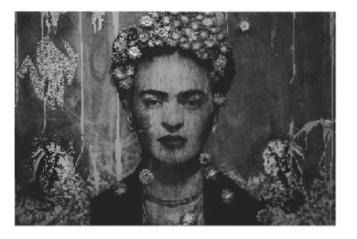

**Program:**

iv.

% Apply non-linear spatial filters with different kernel sizes

filteredImages = cell(1, 3);

for i = 1:length(kernelSizes)

filteredImages{i} = medfilt2(grayImage, [kernelSizes(i), kernelSizes(i)]);

end

% Display or save the filtered images

for i = 1:length(kernelSizes)

imshow(uint8(filteredImages{i}), []);

imwrite(uint8(filteredImages{i}), ['filtered_image_kernel_', num2str(kernelSizes(i)), '.jpg']);

end

**Output:**

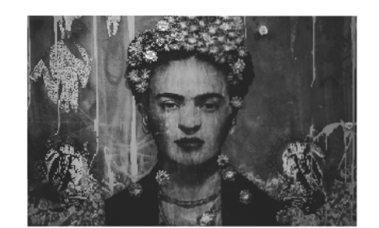

**Program:**

v.

% Read the original image

originalImage = imread('jesse.png');

% Convert the original image to grayscale

grayOriginalImage = rgb2gray(originalImage);

% Add noise to the grayscale image

noisyImage = imnoise(grayOriginalImage, 'gaussian', 0, 0.01); % Adding Gaussian noise

% Apply smoothing spatial filters and non-linear filters to noisy image

smoothedImages = cell(1, length(kernelSizes));

filteredImages = cell(1, length(kernelSizes));

for i = 1:length(kernelSizes)

% Apply smoothing spatial filter (Gaussian blur)

gaussianKernel = fspecial('gaussian', kernelSizes(i), 1);

smoothedImages{i} = imfilter(noisyImage, gaussianKernel, 'replicate');

% Apply non-linear filter (median filter)

filteredImages{i} = medfilt2(noisyImage, [kernelSizes(i), kernelSizes(i)]);

end

% Display the results

figure;

subplot(2, 3, 1), imshow(grayOriginalImage), title('Original Image');

subplot(2, 3, 2), imshow(noisyImage), title('Noisy Image');

subplot(2, 3, 3), imshow(smoothedImages{1}), title('Smoothed (3x3)');

subplot(2, 3, 4), imshow(smoothedImages{2}), title('Smoothed (5x5)');

subplot(2, 3, 5), imshow(smoothedImages{3}), title('Smoothed (7x7)');

subplot(2, 3, 6), imshow(filteredImages{1}), title('Median Filter (3x3)');

% Save the processed images

imwrite(smoothedImages{1}, 'smoothed_3x3.jpg');

imwrite(smoothedImages{2}, 'smoothed_5x5.jpg');

imwrite(smoothedImages{3}, 'smoothed_7x7.jpg');

imwrite(filteredImages{1}, 'median_filter_3x3.jpg');

**Output:**

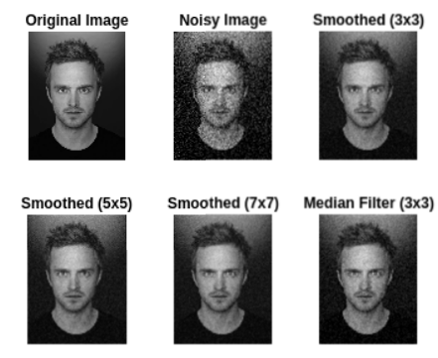

**Program:**

vi.

% Read the original grayscale image

originalImage = imread('jesse.png');

% Apply unsharp masking for sharpening

smoothedImage = imgaussfilt(originalImage, 2); % Example Gaussian filter

unsharpMask = double(originalImage) - double(smoothedImage);

unsharpMaskedImage = double(originalImage) + 1.5 * unsharpMask;

% Apply high-boost filtering for sharpening

highBoostMaskedImage = double(originalImage) + 2 * unsharpMask;

% Convert the results back to uint8 for display

unsharpMaskedImage = uint8(unsharpMaskedImage);

highBoostMaskedImage = uint8(highBoostMaskedImage);

% Display or save the sharpened images

imshow(unsharpMaskedImage);

imwrite(unsharpMaskedImage, 'unsharp_masked_image.jpg');

imshow(highBoostMaskedImage);

imwrite(highBoostMaskedImage, 'high_boost_image.jpg');

**Output:**

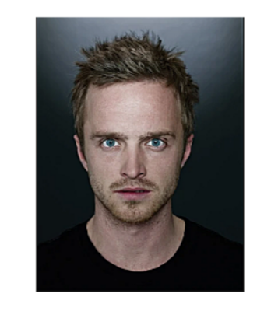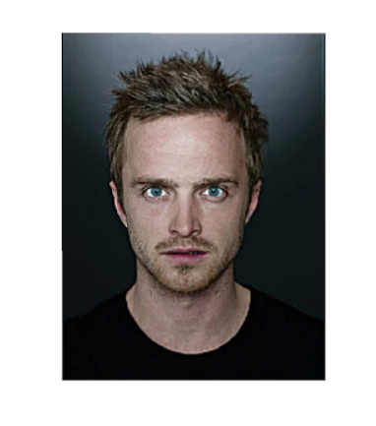

**Conclusion:** In this practical, I leant about spatial domain operations, including cross-correlation, convolution, smoothing, sharpening, non-linear filtering, noise removal, unsharp masking, and high-boost filtering, demonstrating a wide range of image processing techniques.

**PRACTICAL - 5**

**Aim:** Implement code to

i. convert images from space domain to frequency domain and observe their spectrum

ii. observe aliasing in down-sampled images and apply anti-aliasing filter to reduce effect of aliasing

iii. apply frequency domain low-pass filters of different types and cut-off frequencies on images and observe their effects

iv. apply frequency domain high-pass filters of different types and cut-off frequencies on images and observe their effects

v. add periodic noise on images in frequency domain, apply notch filters to remove noise and restore original image

**Program:**

i.

% Read the original image

originalImage = imread('jesse.png');

% Convert image to grayscale if it's a color image

if size(originalImage, 3) == 3

originalImage = rgb2gray(originalImage);

end

% Perform Fourier Transform to convert to frequency domain

frequencyDomainImage = fftshift(fft2(originalImage));

% Calculate magnitude spectrum for visualization

magnitudeSpectrum = abs(frequencyDomainImage);

% Display the magnitude spectrum

imshow(log(1 + magnitudeSpectrum), []);

**Output:**

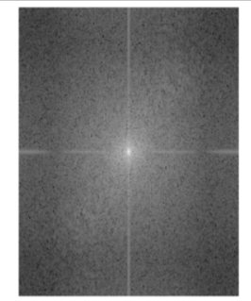

**Program:**

ii.

% Downsample the original image (introducing aliasing)

downsampledImage = imresize(originalImage, 0.5);

% Apply anti-aliasing filter (Gaussian filter in this case)

filteredImage = imgaussfilt(downsampledImage, 1);

% Display the down-sampled and filtered images

figure;

subplot(1, 2, 1), imshow(downsampledImage), title('Down-sampled Image');

subplot(1, 2, 2), imshow(filteredImage), title('Filtered Image');

**Output:**

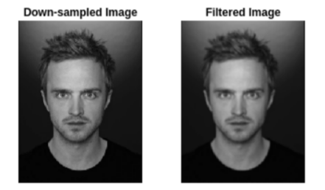

**Program:**

iii.

% Apply frequency domain low-pass filters (e.g., Gaussian filter)

cutoffFrequency = 50;

lowpassFilteredImage = frequencyDomainImage;

lowpassFilteredImage(abs(lowpassFilteredImage) > cutoffFrequency) = 0;

% Inverse Fourier Transform to obtain filtered image

filteredImage = abs(ifft2(ifftshift(lowpassFilteredImage)));

% Display the filtered image

imshow(filteredImage, []);

**Output:**

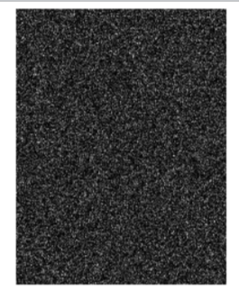

**Program:**

iv.

% Apply frequency domain high-pass filters (e.g., Ideal high-pass filter)

cutoffFrequency = 50;

highpassFilteredImage = frequencyDomainImage;

highpassFilteredImage(abs(highpassFilteredImage) < cutoffFrequency) = 0;

% Inverse Fourier Transform to obtain filtered image

filteredImage = abs(ifft2(ifftshift(highpassFilteredImage)));

% Display the filtered image

imshow(filteredImage, []);

**Output:**

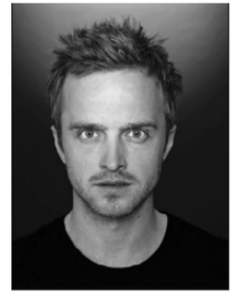

**Program:**

v.

% Add periodic noise in frequency domain

noiseAmplitude = 20;

noiseFrequencyX = 50;

noiseFrequencyY = 30;

noisyFrequencyDomainImage = frequencyDomainImage;

noisyFrequencyDomainImage(noiseFrequencyY, noiseFrequencyX) = ...

noisyFrequencyDomainImage(noiseFrequencyY, noiseFrequencyX) + noiseAmplitude;

% Apply notch filters to remove noise

notchFilterRadius = 10;

notchFilter = ones(size(noisyFrequencyDomainImage));

notchFilter(noiseFrequencyY-notchFilterRadius:noiseFrequencyY+notchFilterRadius, ...

noiseFrequencyX-notchFilterRadius:noiseFrequencyX+notchFilterRadius) = 0;

denoisedFrequencyDomainImage = noisyFrequencyDomainImage .* notchFilter;

% Inverse Fourier Transform to obtain denoised image

denoisedImage = abs(ifft2(ifftshift(denoisedFrequencyDomainImage)));

% Display the noisy and denoised images

figure;

subplot(1, 2, 1), imshow(abs(ifft2(ifftshift(noisyFrequencyDomainImage))), []), title('Noisy Image');

subplot(1, 2, 2), imshow(denoisedImage, []), title('Denoised Image');

**Output:**

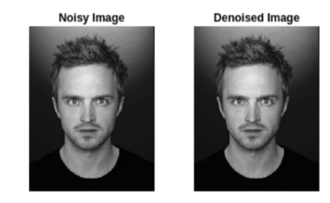

**Conclusion:** In this practical, I leant about aliasing and removing noise from images.

**PRACTICAL - 6**

**Aim:** Implement code to detect

i. edges in different images using laplacian operator

ii. edges in different images using sobel operator

iii. edges in different images using prewitt operator

iv. edges in different images using canny operator

v. lines in different images using Hough Transform

**Program:**

i.

% Apply Laplacian operator for edge detection

laplacianEdges = edge(grayImage, 'log');

% Display or save the edges detected using Laplacian operator

imshow(laplacianEdges);

imwrite(laplacianEdges, 'laplacian_edges.jpg');

**Output:**

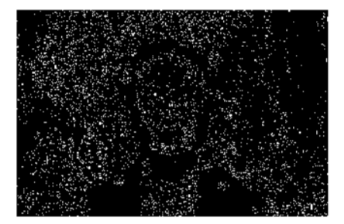

**Program:**

ii.

% Apply Sobel operator for edge detection (horizontal and vertical edges)

sobelEdges = edge(grayImage, 'sobel');

% Display or save the edges detected using Sobel operator

imshow(sobelEdges);

imwrite(sobelEdges, 'sobel_edges.jpg');

**Output:**

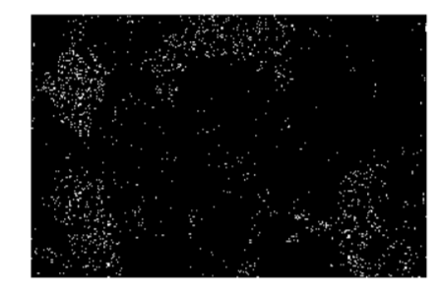

**Program:**

iii.

% Apply Prewitt operator for edge detection (horizontal and vertical edges)

prewittEdges = edge(grayImage, 'prewitt');

% Display or save the edges detected using Prewitt operator

imshow(prewittEdges);

imwrite(prewittEdges, 'prewitt_edges.jpg');

**Output:**

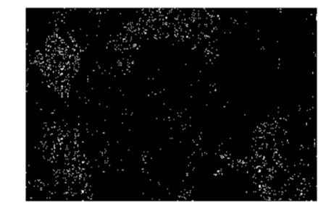

**Program:**

iv.

% Apply Canny operator for edge detection

cannyEdges = edge(grayImage, 'canny');

% Display or save the edges detected using Canny operator

imshow(cannyEdges);

imwrite(cannyEdges, 'canny_edges.jpg');

**Output:**

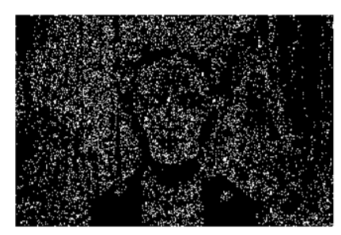

**Program:**

v.

% Apply edge detection (e.g., Canny) for better Hough transform results

edges = edge(grayImage, 'canny');

% Perform Hough Transform for line detection

[H,theta,rho] = hough(edges);

peaks = houghpeaks(H, 10); % Specify the number of peaks to detect

% Find lines in the image

lines = houghlines(edges, theta, rho, peaks);

% Draw lines on the original color image

figure, imshow(originalImage), hold on

for k = 1:length(lines)

xy = [lines(k).point1; lines(k).point2];

plot(xy(:,1), xy(:,2), 'LineWidth', 2, 'Color', 'r');

end

hold off;

% Display or save the image with detected lines

imwrite(originalImage, 'lines_detected_image.jpg');

**Output:**

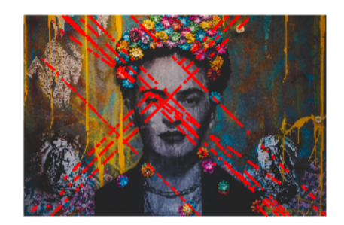

**Conclusion:** In this practical, I implementedvarious edge detection operators, including Laplacian, Sobel, Prewitt, and Canny, as well as the Hough Transform for line detection.

**PRACTICAL - 7**

**Aim:** Implement code to detect features using

i. Harris corner detector

ii. Shi-Tomasi corner detector

iii. Scale Invariant Feature Transform (SIFT)

iv. Speeded up Robust Feature (SURF)

v. Oriented FAST and Rotated BRIEF (ORB)

**Program:**

import cv2

import numpy as np

import matplotlib.pyplot as plt

image_path = "/content/pexels-brett-sayles-6424244 (1).jpg"

image = cv2.imread(image_path)

gray_image = cv2.cvtColor(image, cv2.COLOR_BGR2GRAY)

# Detect corners using Harris corner detector

corner_image = cv2.cornerHarris(gray_image, blockSize=2, ksize=3, k=0.04)

# Threshold the corner response to identify strong corners

threshold = 0.01 * corner_image.max()

corner_image[corner_image < threshold] = 0

# Dilate the corners to make them more visible

corner_image_dilated = cv2.dilate(corner_image, None)

# Mark detected corners on the original image

image_with_corners = image.copy()

image_with_corners[corner_image_dilated > 0.01 * corner_image_dilated.max()] = [0, 0, 255] # Red color

# Display the original image with detected corners

plt.figure(figsize=(12, 6))

plt.subplot(121), plt.imshow(cv2.cvtColor(image, cv2.COLOR_BGR2RGB)), plt.title('Original Image')

plt.subplot(122), plt.imshow(cv2.cvtColor(image_with_corners, cv2.COLOR_BGR2RGB)), plt.title('Image with Detected Corners')

plt.show()

# Detect corners using Shi-Tomasi corner detector

corners = cv2.goodFeaturesToTrack(gray_image, maxCorners=100, qualityLevel=0.01, minDistance=10)

# Convert corners to integer coordinates

corners = np.int0(corners)

# Draw detected corners on the original image

image_with_corners = image.copy()

for corner in corners:

x, y = corner.ravel()

cv2.circle(image_with_corners, (x, y), 3, 255, -1) # Draw a circle at each corner

# Display the original image with detected corners

plt.figure(figsize=(12, 6))

plt.subplot(121), plt.imshow(cv2.cvtColor(image, cv2.COLOR_BGR2RGB)), plt.title('Original Image')

plt.subplot(122), plt.imshow(cv2.cvtColor(image_with_corners, cv2.COLOR_BGR2RGB)), plt.title('Image with Detected Corners')

plt.show()

# Create an SIFT object

sift = cv2.SIFT_create()

# Detect keypoints and compute descriptors

keypoints, descriptors = sift.detectAndCompute(gray_image, None)

# Draw detected keypoints on the original image

image_with_keypoints = cv2.drawKeypoints(image, keypoints, None)

# Display the original image with detected keypoints

plt.figure(figsize=(12, 6))

plt.subplot(121), plt.imshow(cv2.cvtColor(image, cv2.COLOR_BGR2RGB)), plt.title('Original Image')

plt.subplot(122), plt.imshow(cv2.cvtColor(image_with_keypoints, cv2.COLOR_BGR2RGB)), plt.title('Image with Detected Keypoints')

plt.show()

# Create a SURF object

surf = cv2.SURF_create()

# Detect keypoints and compute descriptors

keypoints, descriptors = surf.detectAndCompute(gray_image, None)

# Draw detected keypoints on the original image

image_with_keypoints = cv2.drawKeypoints(image, keypoints, None, (0, 255, 0), 4)

# Display the original image with detected keypoints

plt.figure(figsize=(12, 6))

plt.subplot(121), plt.imshow(cv2.cvtColor(image, cv2.COLOR_BGR2RGB)), plt.title('Original Image')

plt.subplot(122), plt.imshow(cv2.cvtColor(image_with_keypoints, cv2.COLOR_BGR2RGB)), plt.title('Image with Detected Keypoints')

plt.show()

# Create an ORB object

orb = cv2.ORB_create()

# Detect keypoints and compute descriptors

keypoints, descriptors = orb.detectAndCompute(gray_image, None)

# Draw detected keypoints on the original image

image_with_keypoints = cv2.drawKeypoints(image, keypoints, None, (0, 255, 0), 4)

# Display the original image with detected keypoints

plt.figure(figsize=(12, 6))

plt.subplot(121), plt.imshow(cv2.cvtColor(image, cv2.COLOR_BGR2RGB)), plt.title('Original Image')

plt.subplot(122), plt.imshow(cv2.cvtColor(image_with_keypoints, cv2.COLOR_BGR2RGB)), plt.title('Image with Detected Keypoints')

plt.show()

**Output:**

i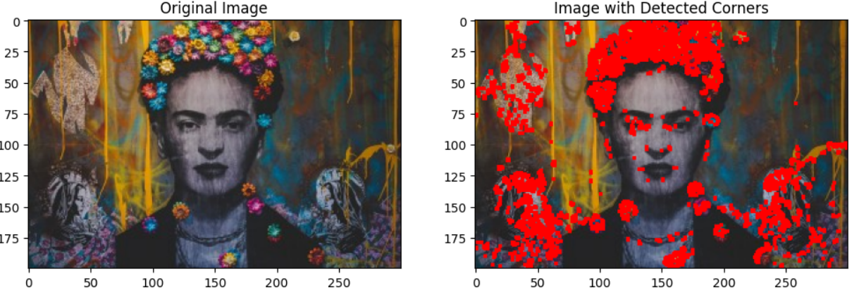

ii 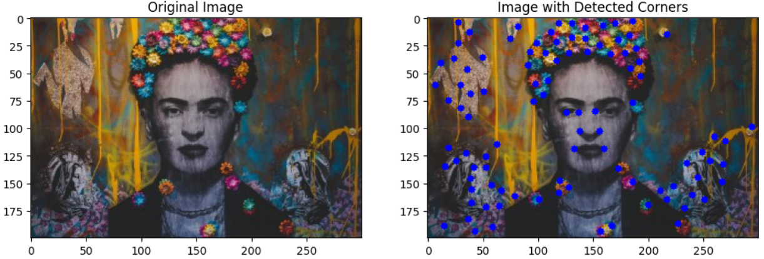

iii 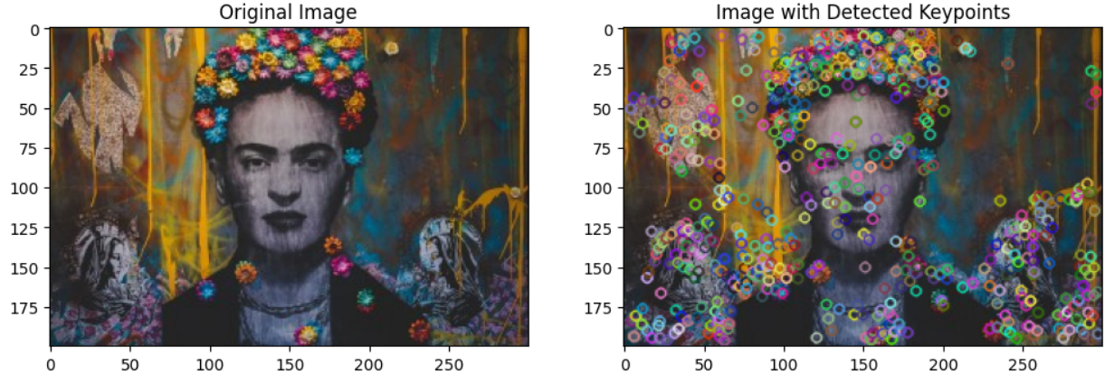

v 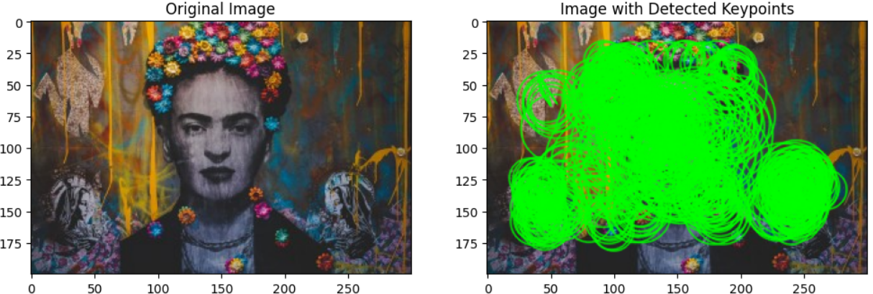

**Conclusion:** In this practical, I learnt various feature detection methods, including Harris and Shi-Tomasi corner detectors, SIFT, SURF, and ORB, for feature-based image analysis.

**PRACTICAL - 8**

**Aim:** Implement a code to segment an image

i. of mutually touching coins using distance transform along with

watershed algorithms.

ii. using the K-means algorithm.

iii. using the Grabcut algorithm.

**Program:**

import cv2

import numpy as np

import matplotlib.pyplot as plt

image_path = "/content/pexels-brett-sayles-6424244 (1).jpg"

image = cv2.imread(image_path)

gray_image = cv2.cvtColor(image, cv2.COLOR_BGR2GRAY)

# Threshold the grayscale image to create a binary mask of the coins

_, binary_mask = cv2.threshold(gray_image, 0, 255, cv2.THRESH_BINARY_INV + cv2.THRESH_OTSU)

# Perform morphological operations to remove noise and separate touching coins

kernel = np.ones((3, 3), np.uint8)

opening = cv2.morphologyEx(binary_mask, cv2.MORPH_OPEN, kernel, iterations=2)

# Calculate the distance transform

dist_transform = cv2.distanceTransform(opening, cv2.DIST_L2, 5)

_, sure_foreground = cv2.threshold(dist_transform, 0.7 * dist_transform.max(), 255, 0)

# Find sure background

sure_background = cv2.dilate(opening, kernel, iterations=3)

# Subtract sure background from sure foreground to get unknown region

sure_foreground = np.uint8(sure_foreground)

unknown = cv2.subtract(sure_background, sure_foreground)

# Label markers for watershed

_, markers = cv2.connectedComponents(sure_foreground)

# Add 1 to all labels to ensure that sure background is not 0 (unlabeled)

markers = markers + 1

markers[unknown == 255] = 0

# Apply the watershed algorithm

cv2.watershed(image, markers)

image[markers == -1] = [0, 0, 255] # Mark segmented regions in red

# Display the original image with segmented coins

plt.figure(figsize=(12, 6))

plt.subplot(121), plt.imshow(cv2.cvtColor(image, cv2.COLOR_BGR2RGB)), plt.title('Original Image')

plt.subplot(122), plt.imshow(markers, cmap='tab20'), plt.title('Segmented Regions')

plt.show()

image = cv2.cvtColor(image, cv2.COLOR_BGR2RGB) # Convert to RGB

# Reshape the image to a 2D array of pixels

pixels = image.reshape(-1, 3)

# Define the number of clusters (K)

K = 3

# Apply K-means clustering

criteria = (cv2.TERM_CRITERIA_EPS + cv2.TERM_CRITERIA_MAX_ITER, 100, 0.2)

_, labels, centers = cv2.kmeans(np.float32(pixels), K, None, criteria, 10, cv2.KMEANS_RANDOM_CENTERS)

# Convert the labels to 8-bit for visualization

labels = labels.reshape(image.shape[0], image.shape[1]).astype(np.uint8)

# Create a mask for each segment

segmented_images = []

for i in range(K):

mask = np.where(labels == i, 255, 0).astype(np.uint8)

segmented_images.append(mask)

# Display the original image and segmented images

plt.figure(figsize=(12, 6))

plt.subplot(131), plt.imshow(image), plt.title('Original Image')

plt.subplot(132), plt.imshow(segmented_images[0], cmap='gray'), plt.title('Segment 1')

plt.subplot(133), plt.imshow(segmented_images[1], cmap='gray'), plt.title('Segment 2')

plt.show()

# Create a mask and initialize it with zeros

mask = np.zeros(image.shape[:2], np.uint8)

# Define a rectangular region of interest (ROI) for initialization

rect = (50, 50, image.shape[1] - 50, image.shape[0] - 50)

# Initialize the GrabCut algorithm with the image, mask, and ROI

bgdModel = np.zeros((1, 65), np.float64)

fgdModel = np.zeros((1, 65), np.float64)

cv2.grabCut(image, mask, rect, bgdModel, fgdModel, 5, cv2.GC_INIT_WITH_RECT)

# Modify the mask to create a binary mask for the foreground

mask2 = np.where((mask == 2) | (mask == 0), 0, 1).astype('uint8')

# Multiply the original image with the binary mask to extract the segmented object

segmented_image = image * mask2[:, :, np.newaxis]

# Display the original image and the segmented result

plt.figure(figsize=(12, 6))

plt.subplot(121), plt.imshow(image), plt.title('Original Image')

plt.subplot(122), plt.imshow(segmented_image), plt.title('Segmented Image')

plt.show()

**Output:**

i 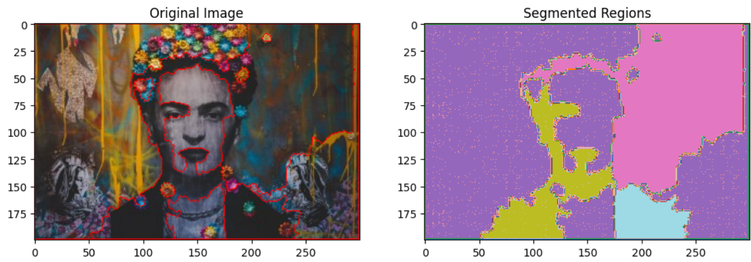

ii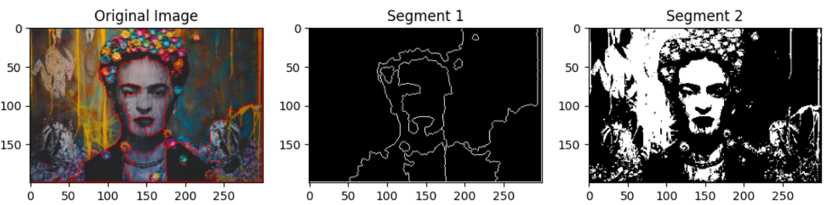

iii 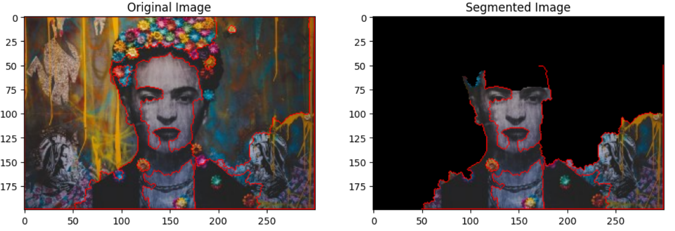

**Conclusion:** In this practical, I segmented images of mutually touching coins by employing distance transform with watershed, K-means, and Grabcut algorithms

**PRACTICAL - 9**

**Aim:** i. Implement face detection and eye detection using HAAR cascade classifiers.

ii. Implement face detection using Viola Jones method and Adaboost training algorithm.

iii. Implement car detection and pedestrian detection using HAAR cascade classifiers.

**Program:**

import cv2

from google.colab.patches import cv2_imshow # Import cv2_imshow for Colab

import matplotlib.pyplot as plt

# Load pre-trained HAAR cascade classifiers for face and eye detection

face_cascade = cv2.CascadeClassifier(cv2.data.haarcascades + 'haarcascade_frontalface_default.xml')

eye_cascade = cv2.CascadeClassifier(cv2.data.haarcascades + 'haarcascade_eye.xml')

# Load an image

image_path = "/content/saulgoodman.png"

image = cv2.imread(image_path)

gray_image = cv2.cvtColor(image, cv2.COLOR_BGR2GRAY)

# Detect faces in the image

faces = face_cascade.detectMultiScale(gray_image, scaleFactor=1.3, minNeighbors=5, minSize=(30, 30))

# Iterate over detected faces and draw rectangles around them

for (x, y, w, h) in faces:

cv2.rectangle(image, (x, y), (x + w, y + h), (255, 0, 0), 2)

roi_gray = gray_image[y:y + h, x:x + w]

roi_color = image[y:y + h, x:x + w]

# Detect eyes within each face region

eyes = eye_cascade.detectMultiScale(roi_gray)

for (ex, ey, ew, eh) in eyes:

cv2.rectangle(roi_color, (ex, ey), (ex + ew, ey + eh), (0, 255, 0), 2)

# Display the image with detected faces and eyes using cv2_imshow

cv2_imshow(image)

# Detect faces in the image

faces = face_cascade.detectMultiScale(image, scaleFactor=1.3, minNeighbors=5, minSize=(30, 30))

# Draw rectangles around detected faces

for (x, y, w, h) in faces:

cv2.rectangle(image, (x, y), (x + w, y + h), (255, 0, 0), 2)

# Display the image with detected faces

cv2_imshow(image)

cv2.waitKey(0)

cv2.destroyAllWindows()

# Specify the paths to the Haar cascade XML files

car_cascade_path = '/content/haarcascade_car.xml'

pedestrian_cascade_path = '/content/haarcascade_fullbody.xml'

# Load the Haar cascade classifiers for car and pedestrian detection

car_cascade = cv2.CascadeClassifier(car_cascade_path)

pedestrian_cascade = cv2.CascadeClassifier(pedestrian_cascade_path)

# Load an image for detection

image_path = "/content/anthony-rosset-YLaLy6wlDiY-unsplash.jpg"

image = cv2.imread(image_path)

gray_image = cv2.cvtColor(image, cv2.COLOR_BGR2GRAY)

# Detect cars in the image

cars = car_cascade.detectMultiScale(gray_image, scaleFactor=1.1, minNeighbors=5, minSize=(20, 20))

# Detect pedestrians in the image

pedestrians = pedestrian_cascade.detectMultiScale(gray_image, scaleFactor=1.1, minNeighbors=5, minSize=(20, 20))

# Brighter colors for drawing rectangles

car_color = (0, 0, 255) # Bright red (BGR color format)

pedestrian_color = (0, 255, 0) # Bright green (BGR color format)

# Line thickness for drawing rectangles

line_thickness = 8 # Adjust as needed for thicker borders

# Loop through the detected cars and draw rectangles with thicker borders

for (x, y, w, h) in cars:

cv2.rectangle(image, (x, y), (x + w, y + h), car_color, line_thickness)

# Loop through the detected pedestrians and draw rectangles with thicker borders

for (x, y, w, h) in pedestrians:

cv2.rectangle(image, (x, y), (x + w, y + h), pedestrian_color, line_thickness)

# Convert the image from BGR to RGB for displaying with matplotlib

image_rgb = cv2.cvtColor(image, cv2.COLOR_BGR2RGB)

# Display the image with detected cars and pedestrians

plt.imshow(image_rgb)

plt.axis('off') # Turn off axis labels

plt.show()

**Output:**

i

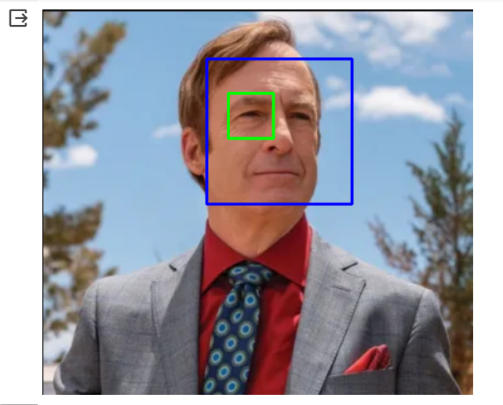

ii

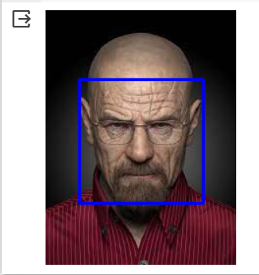

iii

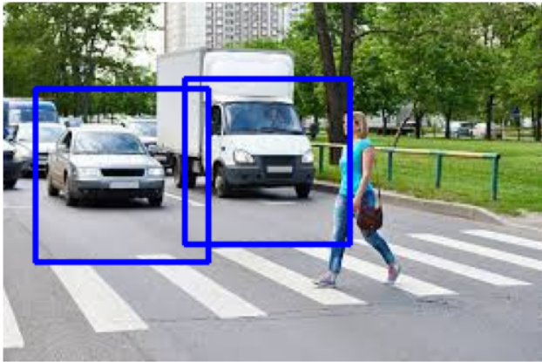

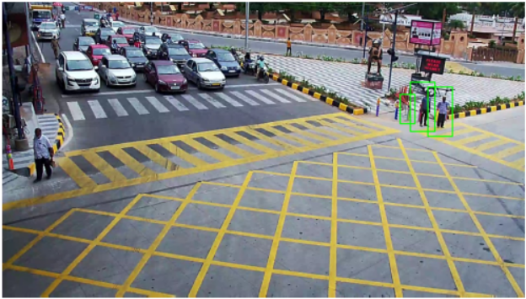

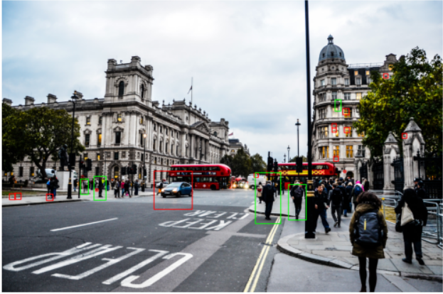

**Conclusion:** In this practical, I applied HAAR cascade classifiers for face, eye, car, and pedestrian detection, demonstrating robust object detection techniques in different contexts.

**PRACTICAL - 10**

**Aim:** i. Implement code to perform feature extraction on given images of faces using Histogram of Gradients.

ii. Implement code to apply Principal Component Analysis on extracted features in objective i.

iii. Implement code to recognize faces using the SVM classifier.

**Program:**

import matplotlib.pyplot as plt

from skimage import io, feature

from skimage.color import rgb2gray

from sklearn.decomposition import PCA

import numpy as np

# Load an image of a face (replace with your image path)

image_path = "/content/download (1).jpeg"

image = io.imread(image_path)

# Convert the image to grayscale

gray_image = rgb2gray(image)

# Compute HOG features

hog_features, hog_image = feature.hog(gray_image, visualize=True)

# Display the original image

plt.figure(figsize=(8, 4))

plt.subplot(121)

plt.imshow(image, cmap='gray')

plt.title('Original Image')

plt.axis('off')

# Display the HOG image

plt.subplot(122)

plt.imshow(hog_image, cmap='gray')

plt.title('HOG Features')

plt.axis('off')

plt.tight_layout()

plt.show()

# Print the HOG feature vector (histogram)

print("HOG Feature Vector (Histogram):")

print(hog_features)

# Extracted HOG features (replace with your own features)

hog_features = np.array([0.1, 0.2, 0.3, 0.4, 0.5, 0.6, 0.7, 0.8, 0.9, 1.0])

# Create a PCA instance without specifying the number of components

pca = PCA()

# Fit the PCA model to the HOG features

pca.fit(hog_features.reshape(-1, 1)) # Reshape to a single feature per sample

# Transform the features into the PCA space

hog_features_pca = pca.transform(hog_features.reshape(-1, 1))

# Explained variance ratio of all components

explained_variance_ratio = pca.explained_variance_ratio_

# Print the transformed features and explained variance

print("Transformed HOG Features (PCA):")

print(hog_features_pca)

print("Explained Variance Ratio:")

print(explained_variance_ratio)

**iii)**

from sklearn.datasets import fetch_lfw_people

faces = fetch_lfw_people(min_faces_per_person=60)

faces.DESCR

import matplotlib.pyplot as plt

fig, splts = plt.subplots(2, 4)

for i, splts in enumerate(splts.flat):

splts.imshow(faces.images[i], cmap='magma')

splts.set(xticks=[], yticks=[],

xlabel=faces.target_names[faces.target[i]])

from sklearn.model_selection import train_test_split

X = faces.data

y = faces.target

X_train, X_test, y_train, y_test = train_test_split(X, y, test_size=0.4, random_state=42)

from sklearn.svm import SVC

from sklearn.decomposition import PCA as RandomizedPCA

from sklearn.pipeline import make_pipeline

# For dimensionality reduction

pca = RandomizedPCA(n_components=150, whiten=True, random_state=42)

svc = SVC(kernel='rbf', class_weight='balanced')

model = make_pipeline(pca, svc)

model.fit(X_train, y_train)

from sklearn.metrics import accuracy_score

predictions = model.predict(X_test)

accuracy_score(predictions, y_test)

from colorama import Fore

incorrect = 0

length = len(predictions)

print("Actual\t\t\t\tPredicted\n")

for i in range(len(predictions)):

if predictions[i] != y_test[i]: # if predictions and actual values are not equal

prediction_name = faces.target_names[predictions[predictions[i]]] # Getting the predicted name

actual_name = faces.target_names[y_test[y_test[i]]] # Getting the actual name

incorrect+=1

print("{}\t\t\t{}".format(Fore.GREEN + actual_name, Fore.RED+prediction_name))

print("{} are classified as correct and {} are classified as incorrect!".format(length-incorrect, incorrect))

**Output:**

i 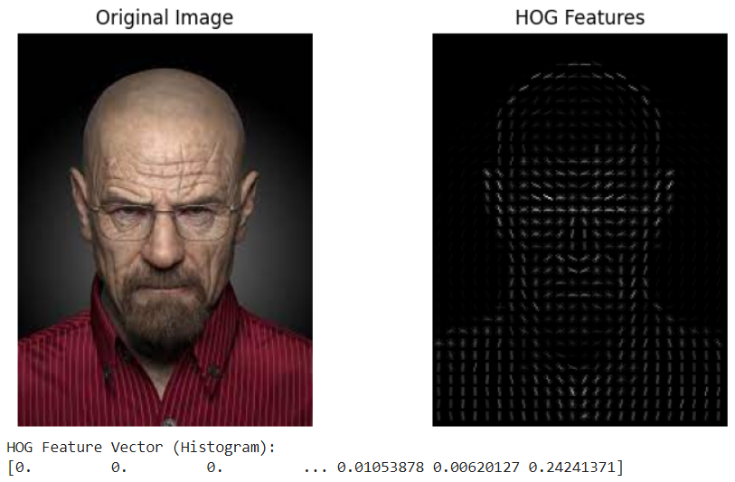

ii

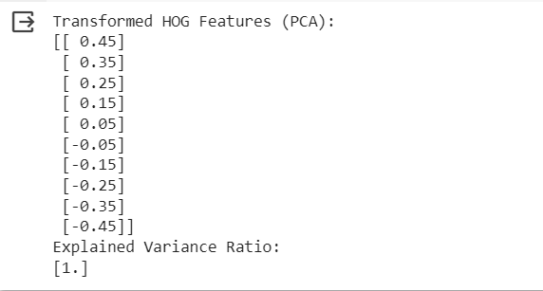

iii

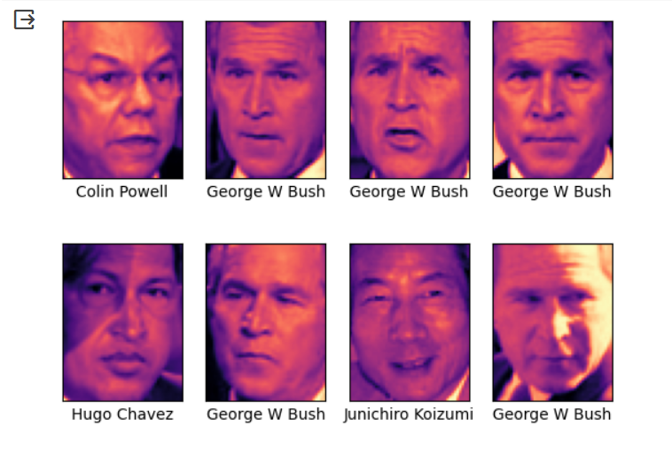

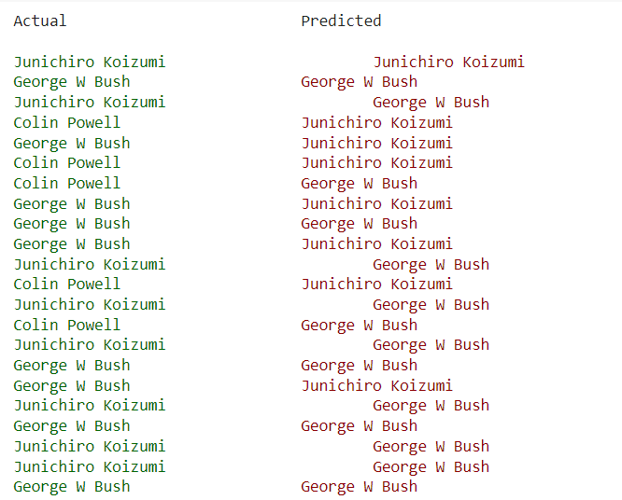

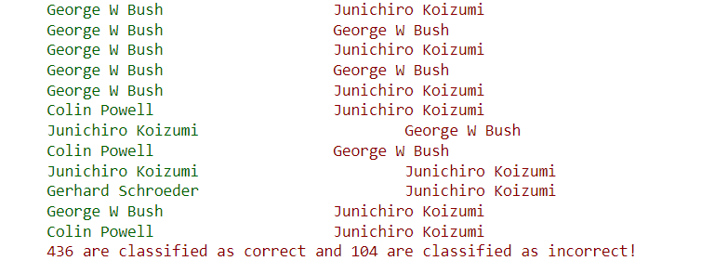

**Conclusion:** In this practical, I performed facial feature extraction with Histogram of Gradients, applied Principal Component Analysis (PCA) on the features, and achieved facial recognition using SVM classifiers.

**PRACTICAL - 11**

**Aim:**

i. Implement code to extract facial landmarks on given images.

ii. Implement code to merge faces (face swaps) using extracted facial landmark features on given images.

iii. Implement code to merge faces (face swaps) using extracted facial landmark features on live video.

**Program:**

import cv2

import dlib

import numpy as np

from google.colab.patches import cv2_imshow

# Load the face detector from dlib (HOG-based)

face_detector = dlib.get_frontal_face_detector()

# Load the facial landmarks predictor from dlib

landmark_predictor = dlib.shape_predictor("/content/drive/MyDrive/shape_predictor_68_face_landmarks.dat")

# Load an image

image_path = "/content/saulgoodman.png"

image = cv2.imread(image_path)

# Convert the image to grayscale (required by dlib)

gray_image = cv2.cvtColor(image, cv2.COLOR_BGR2GRAY)

# Detect faces in the image

faces = face_detector(gray_image)

# Loop over the detected faces

for face in faces:

# Detect facial landmarks

landmarks = landmark_predictor(gray_image, face)

# Loop over the facial landmarks and draw them on the image

for i in range(68):

x, y = landmarks.part(i).x, landmarks.part(i).y

cv2.circle(image, (x, y), 2, (0, 255, 0), -1) # Draw a green circle at each landmark point

# Display the image with facial landmarks

cv2_imshow(image)

# Load the source and target images

source_image = cv2.imread("/content/jesse.png")

target_image = cv2.imread("/content/download (1).jpeg")

# Detect faces in both images

source_faces = face_detector(source_image)

target_faces = face_detector(target_image)

# Ensure one face is detected in each image

if len(source_faces) != 1 or len(target_faces) != 1:

print("Error: Exactly one face must be present in each image.")

else:

# Get facial landmarks for both faces

source_landmarks = landmark_predictor(source_image, source_faces[0])

target_landmarks = landmark_predictor(target_image, target_faces[0])

# Convert landmarks to NumPy arrays

source_landmarks = np.array([[p.x, p.y] for p in source_landmarks.parts()])

target_landmarks = np.array([[p.x, p.y] for p in target_landmarks.parts()])

# Compute the affine transformation matrix

transformation_matrix, _ = cv2.estimateAffinePartial2D(source_landmarks, target_landmarks)

# Warp the source face to match the target face

warped_face = cv2.warpAffine(source_image, transformation_matrix, (target_image.shape[1], target_image.shape[0]))

# Blend the warped face onto the target face

alpha = 0.7 # Adjust this value for blending intensity

beta = 1.0 - alpha

blended_face = cv2.addWeighted(target_image, alpha, warped_face, beta, 0)

# Save or display the resulting image

cv2.imwrite("output_face_swap.jpg", blended_face)

cv2_imshow( blended_face)

**Output:**

i

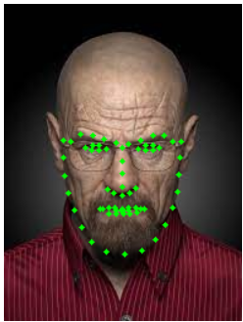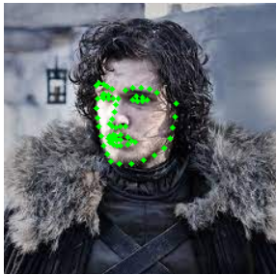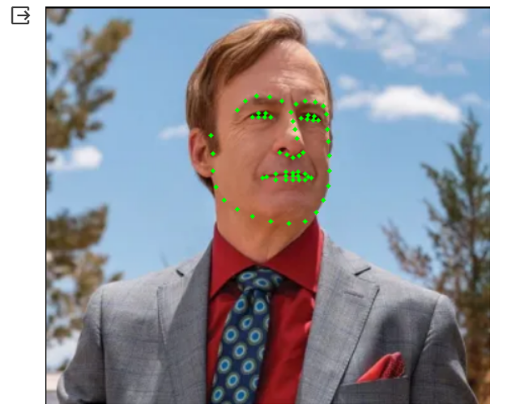

ii

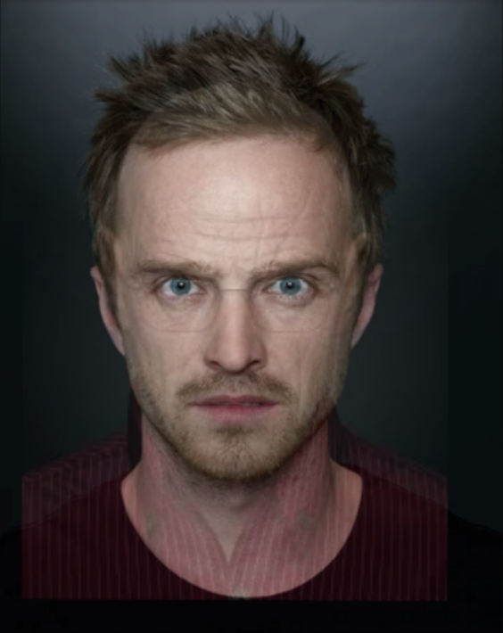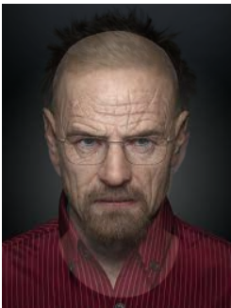

**Conclusion:** In this practical, I extracted facial landmarks, performed face swaps using landmark features on static images, and extended the capability to live video.

**PRACTICAL - 12**

**Aim:** Implement Deep Learning concepts (using DIGITS/TensorFlow/Pytorch)

i. Image Classification

ii. Image Segmentation

iii.Object Detection

iv. Transfer Learning

v. Face Recognition

vi. Emotion Recognition

**Program:**

**Output:**

i

from google.colab import drive

drive.mount('/content/drive')

import tensorflow as tf

from tensorflow import keras

from tensorflow.keras.preprocessing.image import ImageDataGenerator

# Define your dataset directory on Google Colab

dataset_dir = '/content/drive/MyDrive/practical12/traindata/'

# Define hyperparameters

batch_size = 32

epochs = 10

input_shape = (224, 224, 3) # Adjust the input shape according to your images

num_classes = 2 # Change this to the number of classes in your dataset

# Data augmentation and preprocessing

train_datagen = ImageDataGenerator(

rescale=1.0/255.0,

rotation_range=20,

width_shift_range=0.2,

height_shift_range=0.2,

horizontal_flip=True,

shear_range=0.2,

zoom_range=0.2

)

# Create a generator for training data

train_generator = train_datagen.flow_from_directory(

dataset_dir,

target_size=input_shape[:2],

batch_size=batch_size,

class_mode='categorical', # Use 'binary' for binary classification

shuffle=True

)

# Build a convolutional neural network (CNN) model

model = keras.Sequential([

keras.layers.Conv2D(32, (3, 3), activation='relu', input_shape=input_shape),

keras.layers.MaxPooling2D((2, 2)),

keras.layers.Conv2D(64, (3, 3), activation='relu'),

keras.layers.MaxPooling2D((2, 2)),

keras.layers.Conv2D(128, (3, 3), activation='relu'),

keras.layers.MaxPooling2D((2, 2)),

keras.layers.Flatten(),

keras.layers.Dense(128, activation='relu'),

keras.layers.Dense(num_classes, activation='softmax')

])

# Compile the model

model.compile(optimizer='adam',

loss='categorical_crossentropy',

metrics=['accuracy'])

# Train the model

history = model.fit(

train_generator,

steps_per_epoch=len(train_generator),

epochs=epochs

)

# Save the trained model

model.save('image_classification_model.h5')

# Optionally, save training history for analysis

import pickle

with open('training_history.pkl', 'wb') as file:

pickle.dump(history.history, file)

import os

import numpy as np

from tensorflow.keras.preprocessing import image

# Load the trained model

model = keras.models.load_model('image_classification_model.h5')

# Define a function to predict an individual image

def predict_image(image_path):

img = image.load_img(image_path, target_size=(224, 224))

img = image.img_to_array(img)

img = np.expand_dims(img, axis=0)

img = img / 255.0

predictions = model.predict(img)

class_index = np.argmax(predictions)

return class_index

# Define the directory containing test images on Google Colab

test_dir = '/content/drive/MyDrive/practical12/traindata/testimage/'

# Loop through test images and make predictions

for filename in os.listdir(test_dir):

if filename.endswith('.jpg'):

image_path = os.path.join(test_dir, filename)

class_index = predict_image(image_path)

print(f"Image: {filename}, Predicted Class Index: {class_index}")

from google.colab import drive

drive.mount('/content/drive')

import tensorflow as tf

from tensorflow import keras

from tensorflow.keras.preprocessing.image import ImageDataGenerator

# Define your dataset directory on Google Colab

dataset_dir = '/content/drive/MyDrive/practical12/traindata/'

# Define hyperparameters

batch_size = 32

epochs = 10

input_shape = (224, 224, 3) # Adjust the input shape according to your images

num_classes = 2 # Change this to the number of classes in your dataset

# Data augmentation and preprocessing

train_datagen = ImageDataGenerator(

rescale=1.0/255.0,

rotation_range=20,

width_shift_range=0.2,

height_shift_range=0.2,

horizontal_flip=True,

shear_range=0.2,

zoom_range=0.2

)

# Create a generator for training data

train_generator = train_datagen.flow_from_directory(

dataset_dir,

target_size=input_shape[:2],

batch_size=batch_size,

class_mode='categorical', # Use 'binary' for binary classification

shuffle=True

)

# Build a convolutional neural network (CNN) model

model = keras.Sequential([

keras.layers.Conv2D(32, (3, 3), activation='relu', input_shape=input_shape),

keras.layers.MaxPooling2D((2, 2)),

keras.layers.Conv2D(64, (3, 3), activation='relu'),

keras.layers.MaxPooling2D((2, 2)),

keras.layers.Conv2D(128, (3, 3), activation='relu'),

keras.layers.MaxPooling2D((2, 2)),

keras.layers.Flatten(),

keras.layers.Dense(128, activation='relu'),

keras.layers.Dense(num_classes, activation='softmax')

])

# Compile the model

model.compile(optimizer='adam',

loss='categorical_crossentropy',

metrics=['accuracy'])

# Train the model

history = model.fit(

train_generator,

steps_per_epoch=len(train_generator),

epochs=epochs

)

# Save the trained model

model.save('image_classification_model.h5')

# Optionally, save training history for analysis

import pickle

with open('training_history.pkl', 'wb') as file:

pickle.dump(history.history, file)

import os

import numpy as np

from tensorflow.keras.preprocessing import image

# Load the trained model

model = keras.models.load_model('image_classification_model.h5')

# Define a function to predict an individual image

def predict_image(image_path):

img = image.load_img(image_path, target_size=(224, 224))

img = image.img_to_array(img)

img = np.expand_dims(img, axis=0)

img = img / 255.0

predictions = model.predict(img)

class_index = np.argmax(predictions)

return class_index

# Define the directory containing test images on Google Colab

test_dir = '/content/drive/MyDrive/practical12/traindata/testimage/'

# Loop through test images and make predictions

for filename in os.listdir(test_dir):

if filename.endswith('.jpg'):

image_path = os.path.join(test_dir, filename)

class_index = predict_image(image_path)

print(f"Image: {filename}, Predicted Class Index: {class_index}")

ii.

# Setting the dataset path

import pathlib

data_dir = pathlib.Path('/content/gdrive/MyDrive/Segmentation/dataset1')

image_count = len(list(data_dir.glob('*/*.png')))

print(image_count)

dir_data = "/content/gdrive/MyDrive/Segmentation/dataset1/"

dir_seg = dir_data + "/annotations_prepped_train/"

dir_img = dir_data + "/images_prepped_train/"

import cv2, os

import numpy as np

import matplotlib.pyplot as plt

import seaborn as sns

## seaborn has white grid by default so I will get rid of this.

sns.set_style("whitegrid", {'axes.grid' : False})

ldseg = np.array(os.listdir(dir_seg))

## pick the first image file

fnm = ldseg[0]

print(fnm)

## read in the original image and segmentation labels

seg = cv2.imread(dir_seg + fnm ) # (360, 480, 3)

img_is = cv2.imread(dir_img + fnm )

print("seg.shape={}, img_is.shape={}".format(seg.shape,img_is.shape))

## Check the number of labels

mi, ma = np.min(seg), np.max(seg)

n_classes = ma - mi + 1

print("minimum seg = {}, maximum seg = {}, Total number of segmentation classes = {}".format(mi,ma, n_classes))

fig = plt.figure(figsize=(5,5))

ax = fig.add_subplot(1,1,1)

ax.imshow(img_is)

ax.set_title("original image")

plt.show()

fig = plt.figure(figsize=(15,10))

for k in range(mi,ma+1):

ax = fig.add_subplot(3, int(n_classes/3)+1, k+1)

ax.imshow((seg == k)*1.0)

ax.set_title("label = {}".format(k))

plt.show()

import random

def give_color_to_seg_img(seg,n_classes):

'''

seg : (input_width,input_height,3)

'''

if len(seg.shape)==3:

seg = seg[:,:,0]

seg_img = np.zeros( (seg.shape[0],seg.shape[1],3) ).astype('float')

colors = sns.color_palette("hls", n_classes)

for c in range(n_classes):

segc = (seg == c)

seg_img[:,:,0] += (segc*( colors[c][0] ))

seg_img[:,:,1] += (segc*( colors[c][1] ))

seg_img[:,:,2] += (segc*( colors[c][2] ))

return(seg_img)

input_height , input_width = 224 , 224

output_height , output_width = 224 , 224

ldseg = np.array(os.listdir(dir_seg))

for fnm in ldseg[np.random.choice(len(ldseg),3,replace=False)]:

fnm = fnm.split(".")[0]

seg = cv2.imread(dir_seg + fnm + ".png") # (360, 480, 3)

img_is = cv2.imread(dir_img + fnm + ".png")

seg_img = give_color_to_seg_img(seg,n_classes)

fig = plt.figure(figsize=(20,40))

ax = fig.add_subplot(1,4,1)

ax.imshow(seg_img)

ax = fig.add_subplot(1,4,2)

ax.imshow(img_is/255.0)

ax.set_title("original image {}".format(img_is.shape[:2]))

ax = fig.add_subplot(1,4,3)

ax.imshow(cv2.resize(seg_img,(input_height , input_width)))

ax = fig.add_subplot(1,4,4)

ax.imshow(cv2.resize(img_is,(output_height , output_width))/255.0)

ax.set_title("resized to {}".format((output_height , output_width)))

plt.show()

iv.

import tensorflow as tf

from tensorflow.keras.datasets import cifar10

from tensorflow.keras.applications import ResNet50

from tensorflow.keras.layers import GlobalAveragePooling2D, Dense

from tensorflow.keras.models import Model

# Load the CIFAR-10 dataset

(X_train, y_train), (X_test, y_test) = cifar10.load_data()

# Normalize pixel values to between 0 and 1

X_train, X_test = X_train / 255.0, X_test / 255.0

# Load the pre-trained ResNet50 model (excluding the top classification layers)

base_model = ResNet50(weights='imagenet', include_top=False)

# Add custom classification layers on top of the pre-trained model

x = base_model.output

x = GlobalAveragePooling2D()(x)

x = Dense(1024, activation='relu')(x)

predictions = Dense(10, activation='softmax')(x) # Adjust the number of classes

# Create the transfer learning model

model = Model(inputs=base_model.input, outputs=predictions)

# Freeze the layers of the pre-trained model (optional)

for layer in base_model.layers:

layer.trainable = False

# Compile the model

model.compile(optimizer='adam',

loss='sparse_categorical_crossentropy', # Adjust the loss function

metrics=['accuracy'])

# Train the model

history = model.fit(X_train, y_train,

epochs=10, # Adjust the number of epochs

validation_data=(X_test, y_test))

# Evaluate the model

test_loss, test_accuracy = model.evaluate(X_test, y_test)

print(f'Test accuracy: {test_accuracy:.4f}')

v.

#import OpenCV module

import cv2

import os

import numpy as np

import matplotlib.pyplot as plt

%matplotlib inline

#function to detect face

def detect_face (img):

#convert the test image to gray image

gray = cv2.cvtColor (img, cv2.COLOR_BGR2GRAY)

#load OpenCV face detector

face_cas = cv2.CascadeClassifier ('-File name.xml-')

faces = face_cas.detectMultiScale (gray, scaleFactor=1.3, minNeighbors=4);

#if no faces are detected then return image

if (len (faces) == 0):

return None, None

#extract the face

faces [0]=(x, y, w, h)

#return only the face part

return gray[y: y+w, x: x+h], faces [0]

#this function will read all persons' training images, detect face #from each image

#and will return two lists of exactly same size, one list

def prepare_training_data(data_folder_path):

#------STEP-1--------

#get the directories (one directory for each subject) in data folder

dirs = os.listdir(data_folder_path)

faces = []

labels = []

for dir_name in dirs:

#our subject directories start with letter 's' so

#ignore any non-relevant directories if any

if not dir_name.startswith("s"):

continue;

#------STEP-2--------

#extract label number of subject from dir_name

#format of dir name = slabel

#, so removing letter 's' from dir_name will give us label

label = int(dir_name.replace("s", ""))

#build path of directory containin images for current subject subject

#sample subject_dir_path = "training-data/s1"

subject_dir_path = data_folder_path + "/" + dir_name

#get the images names that are inside the given subject directory

subject_images_names = os.listdir(subject_dir_path)

#------STEP-3--------

#go through each image name, read image,

#detect face and add face to list of faces

for image_name in subject_images_names:

#ignore system files like .DS_Store

if image_name.startswith("."):

continue;

#build image path

#sample image path = training-data/s1/1.pgm

image_path = subject_dir_path + "/" + image_name

#read image

image = cv2.imread(image_path)

#display an image window to show the image

cv2.imshow("Training on image...", image)

cv2.waitKey(100)

#detect face

face, rect = detect_face(image)

#------STEP-4--------

#we will ignore faces that are not detected

if face is not None:

#add face to list of faces

faces.append(face)

#add label for this face

labels.append(label)

cv2.destroyAllWindows()

cv2.waitKey(1)

cv2.destroyAllWindows()

return faces, labels

#let's first prepare our training data

#data will be in two lists of same size

#one list will contain all the faces

#and other list will contain respective labels for each face

print("Preparing data...")

faces, labels = prepare_training_data("training-data")

print("Data prepared")

#print total faces and labels

print("Total faces: ", len(faces))

print("Total labels: ", len(labels))

#create our LBPH face recognizer

face_recognizer = cv2.face.createLBPHFaceRecognizer()

#train our face recognizer of our training faces

face_recognizer.train(faces, np.array(labels))

#function to draw rectangle on image

#according to given (x, y) coordinates and

#given width and heigh

def draw_rectangle(img, rect):

(x, y, w, h) = rect

cv2.rectangle(img, (x, y), (x+w, y+h), (0, 255, 0), 2)

#function to draw text on give image starting from

#passed (x, y) coordinates.

def draw_text(img, text, x, y):

cv2.putText(img, text, (x, y), cv2.FONT_HERSHEY_PLAIN, 1.5, (0, 255, 0), 2)

#this function recognizes the person in image passed

#and draws a rectangle around detected face with name of the subject

def predict(test_img):

#make a copy of the image as we don't want to chang original image

img = test_img.copy()

#detect face from the image

face, rect = detect_face(img)

#predict the image using our face recognizer

label= face_recognizer.predict(face)

#get name of respective label returned by face recognizer

label_text = subjects[label]

#draw a rectangle around face detected

draw_rectangle(img, rect)

#draw name of predicted person

draw_text(img, label_text, rect[0], rect[1]-5)

return img

#load test images

test_img1 = cv2.imread("test-data/test1.jpg")

test_img2 = cv2.imread("test-data/test2.jpg")

#perform a prediction

predicted_img1 = predict(test_img1)

predicted_img2 = predict(test_img2)

print("Prediction complete")

#create a figure of 2 plots (one for each test image)

f, (ax1, ax2) = plt.subplots(1, 2, figsize=(10, 5))

#display test image1 result

ax1.imshow(cv2.cvtColor(predicted_img1, cv2.COLOR_BGR2RGB))

#display test image2 result

ax2.imshow(cv2.cvtColor(predicted_img2, cv2.COLOR_BGR2RGB))

#display both images

cv2.imshow("Tom cruise test", predicted_img1)

cv2.imshow("Shahrukh Khan test", predicted_img2)

cv2.waitKey(0)

cv2.destroyAllWindows()

cv2.waitKey(1)

cv2.destroyAllWindows()

vi.

# read image

img = cv2.imread('img1.jpg')

# call imshow() using plt object

plt.imshow(img[:, :, : : -1])

# display that image

plt.show()

# storing the result

result = DeepFace.analyze(img,

actions = ['emotion'])

# print result

print(result)

# import the required modules

import cv2

import matplotlib.pyplot as plt

from deepface import DeepFace

# read image

img = cv2.imread('img.jpg')

# call imshow() using plt object

plt.imshow(img[:,:,::-1])

# display that image

plt.show()

# storing the result

result = DeepFace.analyze(img,actions=['emotion'])

print(result)

**Output:**

i.

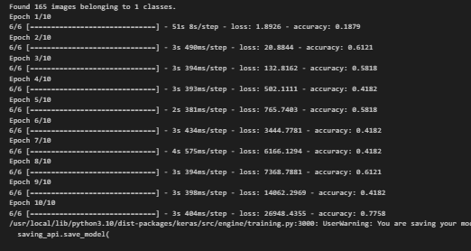

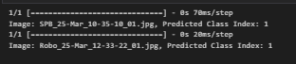

ii.

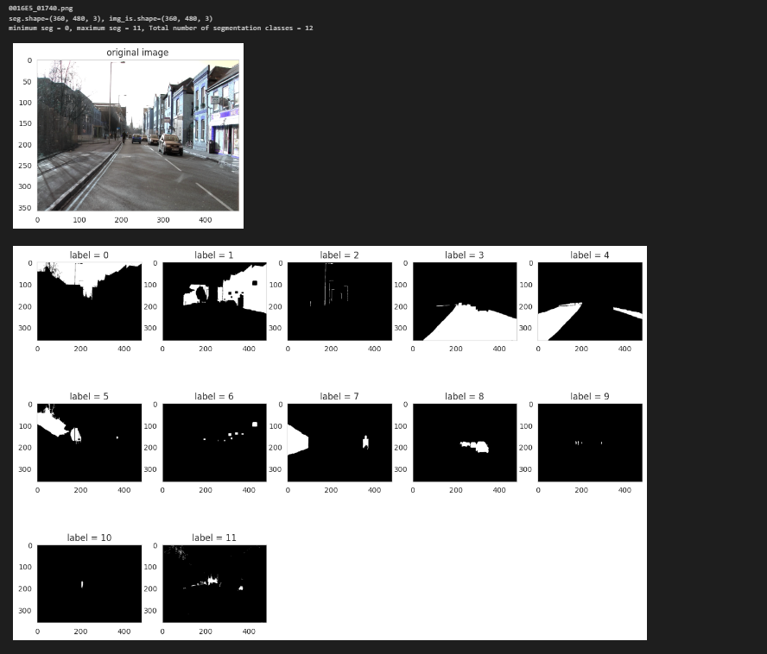

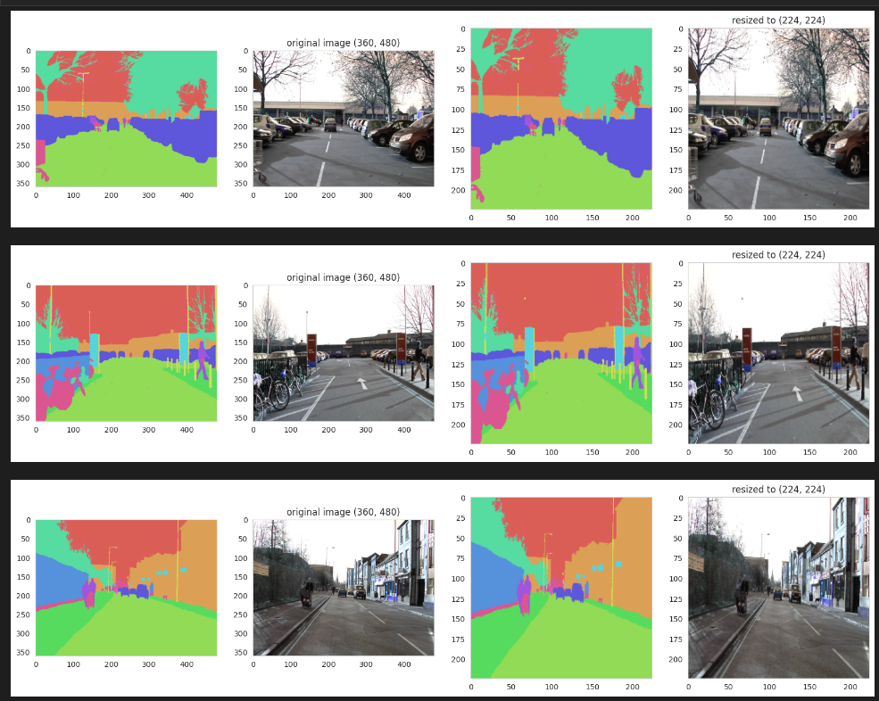

iv.

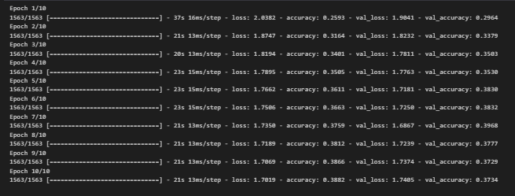



v.

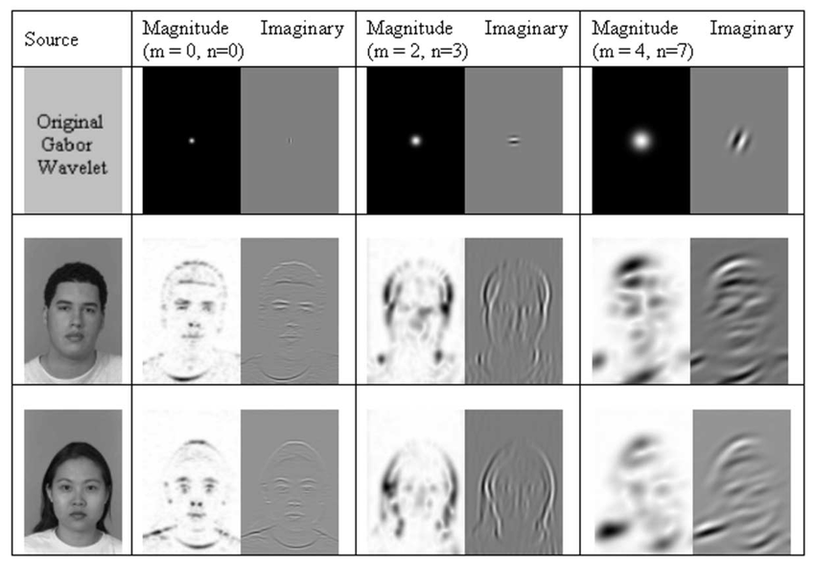

vi.

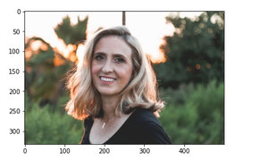

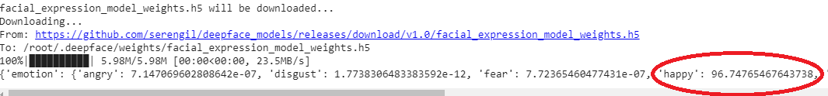



**Conclusion:** In this practical, I implemented deep learning concepts using DIGITS, TensorFlow, and PyTorch covered a wide spectrum of applications, including image classification, segmentation, object detection, transfer learning, face recognition, and emotion recognition